OPERATING SYSTEMS
WEEK-01 PARCTICAL

NAME : BANDARU THRINADH
ROLL NO : 2520030529
SECTION -07

>Develop a C program that uses the system calls open(), read(), write(), and close() to copy the contents of one file to another. Explain how control transitions between user space and kernel space during execution.
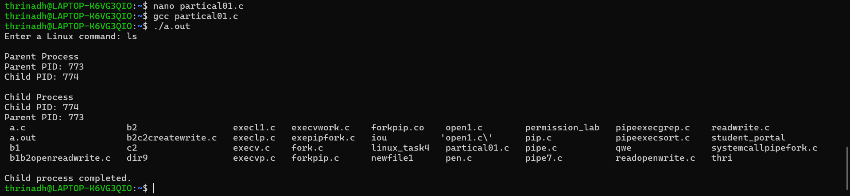

>Using Linux terminal commands (uname, lscpu, lsblk, ps, top), investigate the relationship between hardware resources and operating system services. Prepare a report explaining how the OS abstracts CPU, memory, storage, and I/O devices.
-uname
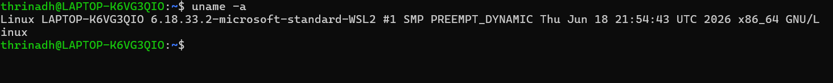
-lscpu
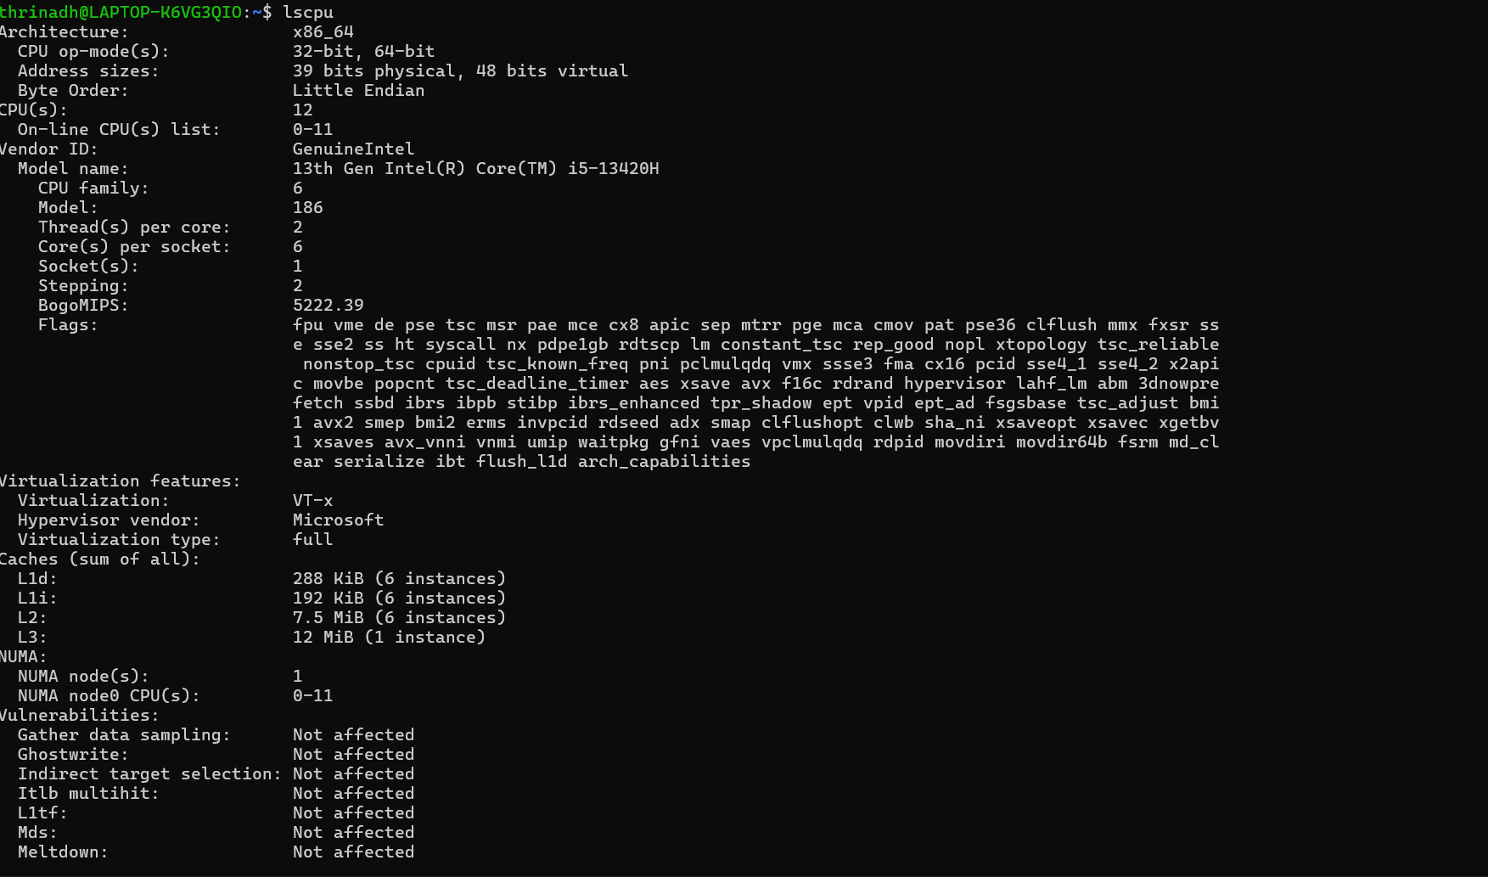
-lsblk
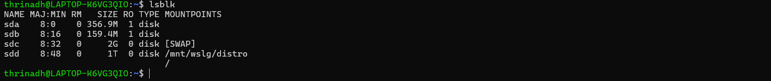
-ps
-top
